How to install Git Bash

Click on right button of mouse, in the list if you not able to find **Git Bash Here** option please follow below steps.

\\Global.lloydstsb.com\file\D_COMMON0044$\Shared\Install

1. Open above shared path in windows
2. Copy **Git-2.8.3-32-bit** application to your local drive

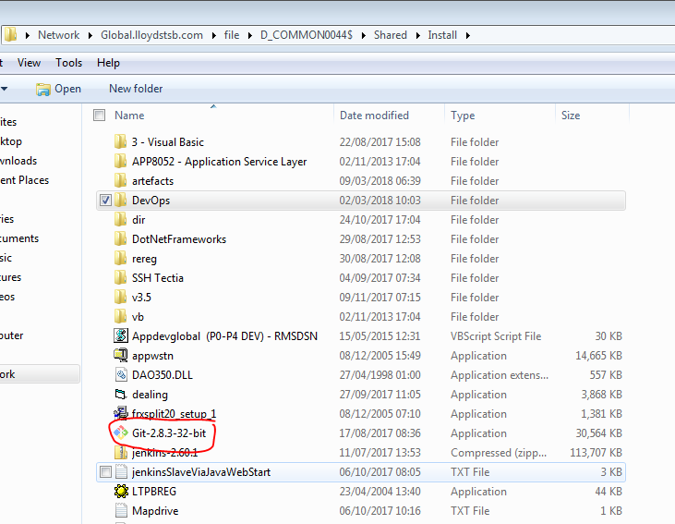

1. After copy, go to path where you copied and double click on application
2. If it ask USER NAME and PASSWORD for changes enter your **GLOBAL ID and PASSWORD**
3. Click on Run

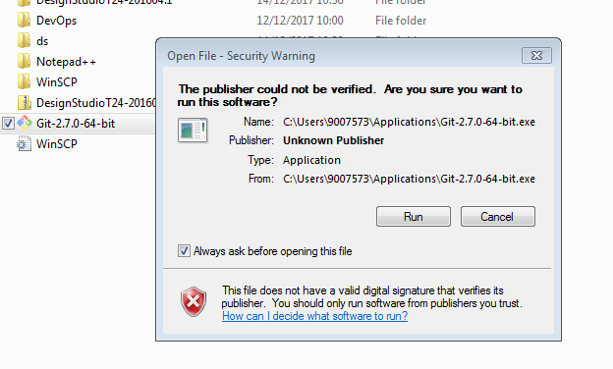

1. Click on next

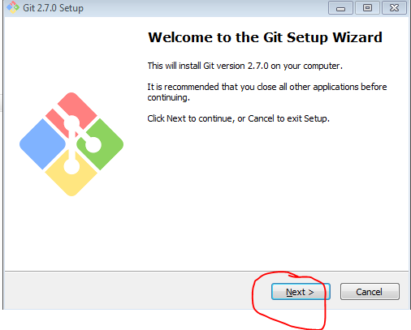

1. Click on next

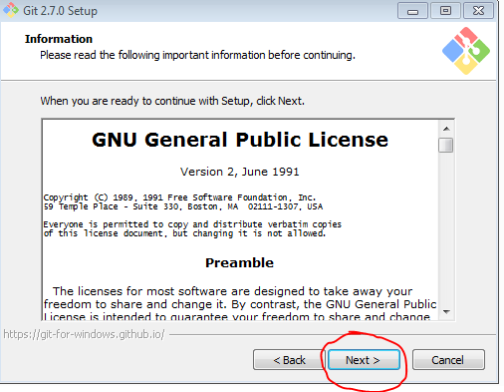

1. Click on next

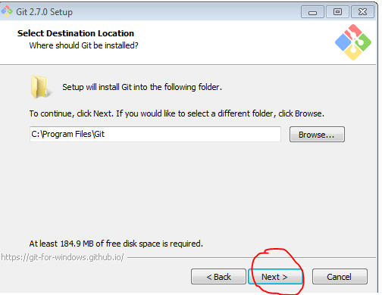

1. Click on next

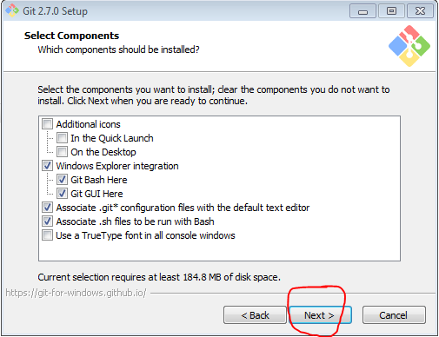

1. Click on next

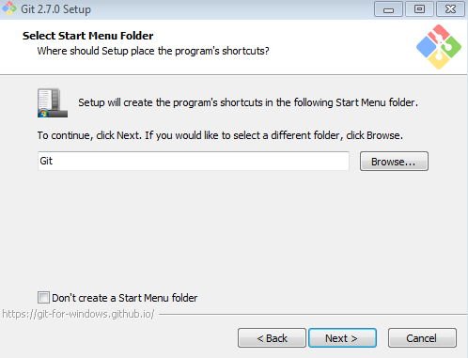

1. Check 2nd option and click on next

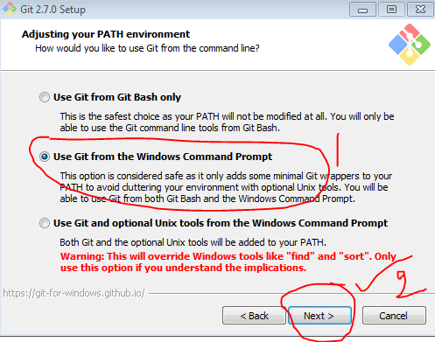

1. Click on next

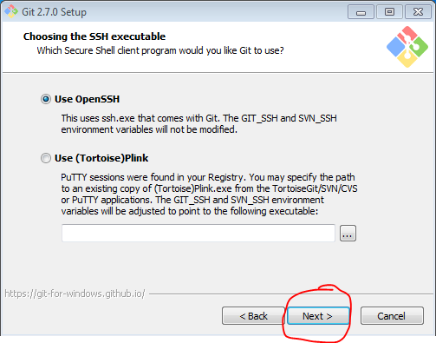

1. Click on next

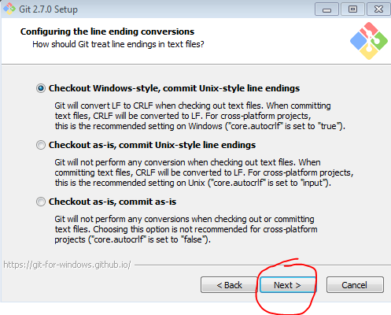

1. Click on next

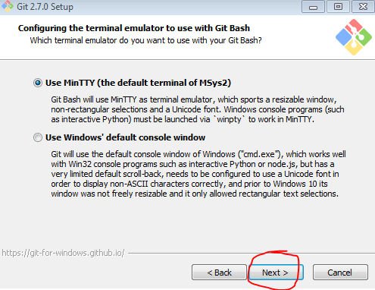

1. Check box and Click on next

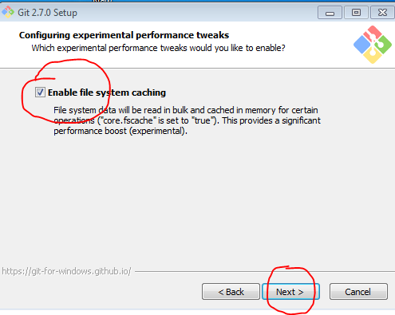

1. Wait up to process complete

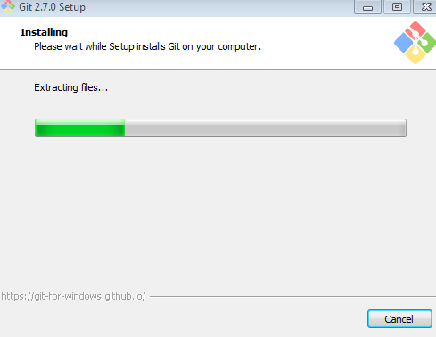

1. Click on finish

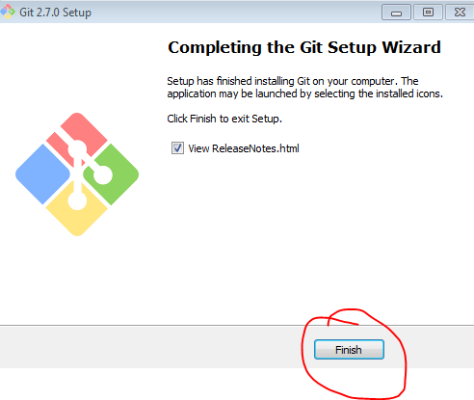

Now click right button on mouse, now you can see Git Bash Here option